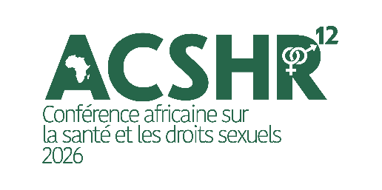
Call for Abstracts – ACSRH 2026
- Launch Date: July 2
- Submission Deadline: August 1 (11:59 p.m. GMT)

- Background
Africa is currently the world’s youngest continent, with nearly 60% of its population under the age of 25. This demographic dynamic represents a major opportunity for the continent’s sustainable development, provided that adolescent girls and young people can fully exercise their rights.
However, implementation gaps are exacerbated by a series of overlapping crises: declining funding, humanitarian emergencies, climate change, and the global rise of anti-rights agendas.

ACSHR 2026 serves as a strategic platform aimed at strengthening coordination among stakeholders and supporting the effective implementation of regional and international commitments, with a focus on youth leadership.

Contributing to the sustainable strengthening of the sexual and reproductive health and rights of adolescents and young people in Africa by promoting coherent, coordinated, and action-oriented policy, programmatic, and financial responses to multifaceted crises and the rise of conservative policies—through a human rights-based approach—ACSRH 2026 will serve as a framework for sharing your commitments and actions.

- Main Theme: “Sexual and Reproductive Health and Rights of Adolescents and Young People in Africa in the Face of Multifaceted Crises.”

- Structural subthemes:
Structural Subtheme 1: Sustainable Financing for SRHR
Structural Subtheme 2: Conservative Dynamics and Policies Against SRHR
Key Subtheme 3: SRHR in Humanitarian and Fragile Contexts
Structural Subtheme 4: Approaches Tailored to the Specific Needs of Adolescents and Young People
Structural Subtheme 5: Dynamics of the fight against gender-based violence

- SRHR Components:
- Family planning,
- Abortion care,
- Comprehensive sexuality education,
- Prevention and management of adolescent pregnancies,
- Prevention of and response to gender-based violence,
- Menstrual health, hygiene, and dignity,
- Genital cancers,
- Infertility,
- Endometriosis
- Access to SRHR services for marginalized individuals and groups
Notes: Please note that SRHR components are not standalone submission categories; we would like these components to be addressed through the lens of at least each of the five overarching subthemes.
- Types of accepted submissions:
- Experience stories / best practices
- Policy analyses / advocacy
- Research findings / case studies
- Community innovations / youth initiatives
- Critical reflections on challenges and lessons learned
- Abstract Outline (required)
Each abstract must follow the following structure:
- Author/Co-author: Last Name & First Name, Affiliation(s), email address
- Introduction: General context and research question
- Objectives: What the contributor wishes to share or demonstrate
- Methodology / Approach: Approach used or type of intervention
- Results / Key Findings: Data, lessons, observations
- Conclusion and Recommendations: Proposed actions or key takeaways

- Cross-cutting approaches used (multiple selections possible)
☐ Human rights-based approach
☐ Feminist approach
☐ Community-based approach
☐ Intersectional approach
☐ Program innovation
☐ Technological innovation
☐ Youth participation and leadership
☐ Inclusion of marginalized populations
☐ Other (please specify)

In 100 words, explain how your contribution incorporates the selected approaches.
……………………………………………………………………………………………………………………………………………………………………………………………………………………………………………………………………………………………………………………………………………………………………………………………………….
- Preferred presentation format:
The jury may suggest a different presentation format during the review process. Please feel free to indicate your preference nonetheless. We encourage creative and varied session formats, depending on the needs of the topic and the target audience. Please specify your preferred format in your submission:
- Individual oral presentation (during a plenary or parallel session)
- Interactive panel
- Capacity-building workshop/training
- Testimony or storytelling
- Artistic session (slam, theater, visual storytelling, etc.)
- Poster session
Original and inclusive formats will be prioritized during the selection process.
- Submission criteria:
- Write an abstract of 500 to 600 words maximum
- Clearly indicate the chosen subtheme
- Specify the desired session format
- Submission language: French or English
- Submission: via the conference website’s “abstracts” section

